Selling Points

- Value Added

A roofing replacement is one of the highest returns on investment you can do for your home. Zillow states that over 73% of the cost of a roofing project is recouped in added value to your home. Pairing that with our industry leading, fully transferrable warranty, this creates a HUGE selling point that can be the difference of THOUSANDS of dollars.

That means this $15,000 on your roof adds over TEN THOUSAND dollars of value to your home!

Who to pitch this to: Customers selling or not in their ‘forever home’, customers conscious about the investment of a new roof, customers interested in VALUE

- FINANCING $$$

Less than 5% of contractors in the United States can offer financing of any kind and less than 1% of contractors in the United States can offer ZERO DOWN financing. This is a RISK FREE, NO MONEY DOWN OPPORTUNITY for them to get the new roof they need at a LOW MONTHY PAYMENT.

Who to pitch this to: Low income, customer who needs a roof but “can’t afford it”

- National Average Pricing

According to the Cost vs Value report for 2023, the average roofing replacement cost was just shy of $30,000 for an asphalt shingle roof. The average price per square foot came out to $8.11 per square foot. This data was the average of ALL the different asphalt shingle roofs: warrantied roofs, non-warrantied roofs, performance grade materials, low grade materials, everything.

Now, we have an industry leading warranty and only use performance grade material and this pricing comes out to less than the national average here at $7.15 per square foot.

Who to pitch this to: Customer who wants other estimates or wants to check out other options

- Price Urgency

Taking a look at the chart below we see the average price for a new roof in 2015 was just under $20k. Nine years later, the average is $31k. That is more than a50% increase in just 9 years. A roofing replacement will never be cheaper than it is now. You are never going to wake up and say, “wow I’m so excited to get my roof replaced.” This is a necessary replacement to protect your most valuable asset and know it is backed by an industry leading warranty.

Asphalt is a petroleum-based product, meaning it is produced with petroleum. Petroleum is gas. Remember when gas was $1 a gallon? Now its pushing $4 a gallon. Materials pricing is constantly going up with inflation. We get 4-5 price increases EVERY year from our manufacturer. The longer you wait, the more expensive this becomes.
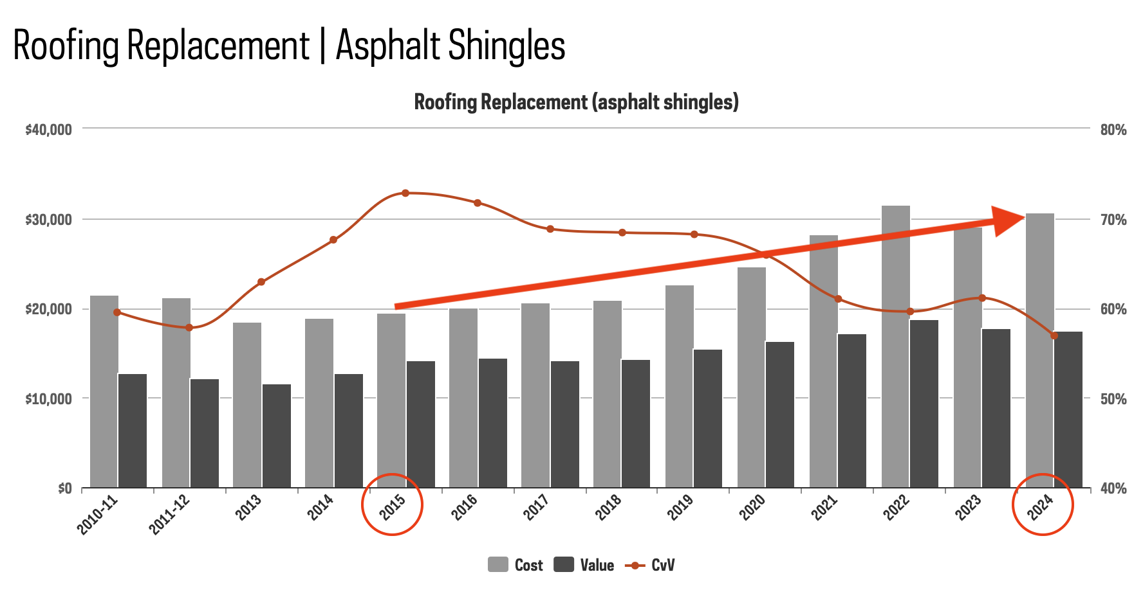

Who to pitch this to: customers on the fence about pricing or want to wait until…

- Fear of Bad Contractor

Less than 5% of contractors in the country are licensed, bonded, and fully insured (most are under insured). Less than 10% of contractors make it past 5 years of business. Less than 1% of roofing contractors have a 50-year warranty and use performance grade products and 0% of them that do can match my pricing. These are the facts.

I have heard the horror stories of people going the cheapest route and having a leak within 6 months and can never reach the contractor.

I know if you go with 99% of contractors you are rolling the dice. If you go with me, I know what product you are getting, I know what warranty you are getting. You never have to worry about your roof again.

Who to pitch this to: Customers who have had a bad contractor experience, lack trust, or have a much cheaper quote

- “Price is too high”

Possible response:

“Do you mean the price, or do you mean the cost?”

WAIT AND MAKE THEM ANSWER - Chances are they will say: “what do you mean” or “what’s the difference.”

Price is what you pay today, cost is what you pay 2-5-10-20 years down the road.

If you want a cheap and unwarranted product, you save a few bucks today sure but repair fees down the road are going to cost you 10 times more.

Yes, with us the price today is higher, but you will save THOUSANDS never having to do this again and never having to pay for repairs. With the cheap roofing system your price is slightly less today but the future costs are literally unlimited - with our product we know your future costs are exactly $0.

Why do you think so many people still choose us (being a top 8 roofing company in the country) when there are cheaper options out there?

You pay the price now, with easy monthly payments, and you never have to worry about spending a single penny again on this roof. You go with the cheap roof, you have to worry about it every time it rains from now until that first leak happens which is an not an if, its a when.
- Breaking Down Other Options

“Eh, I really want to get other estimates here”

Why do they want other estimates? Because this isn’t like buying milk or buying a t shirt or even a car - they have zero education have have no fucking clue what this shit should cost. They buy milk every week, car every few years, roof - essentially never.

Builders grade - Cheapest cost but lowest quality materials, no warranties, and lifespan will be short = shortest time between doing the project again - can be as short as 6 months (ive literally seen it)

==== $$$ Give out our price 3 number as a normal builders grade cost for their size roof.

For a roof your size, a typical builders grade roof would cost around $19,000 (around whatever price 3 is)

Mid-grade - slightly higher quality materials, little longer lifespan but still won’t have warranties to back the product when issues arise,

=== $$$ Give price 2 here for your size roof

For a roof your size, a typical mid-grade roof would cost around X (around whatever price 2 is)

Performance grade - highest quality, longest lifespan, best warranties. This is what we always recommend because according to real estate data, this is always the best value and most cost effective long term - meaning this will cost the least in the long run because you never have to do it again. This is where we come in at a pricing at $21,321

————————————————————

What I can do here is look to apply this grant/discount/rebate to save you nearly $2,000 and get you down to $19,056 - essentially what you would be looking to pay for a mid grade roofing system here.

WAIT FOR THE OBJECTION

Fight the objection - talk to them about why what we do is superior - why our pricing is worth it.

Final price drop to price 3 – They are essentially getting the performance grade roof for the price of a builders grade roof

“Look I get 1 family/friends discount per year to apply for a job that is $1,500 - I haven’t used it and I don’t plan on using it. I can get this down to $17,556 which is going to literally be what you would pay for an unwarranted roof.

LET THEM GIVE AN OBJECTION

All else fails - that’s when you use the get as many estimates as you want. I’ll price match because I know it is IMPOSSIBLE to get to this price for what we are offering.

Who to pitch this to: Customer who wants other estimates

- Warranty/$0 down/low monthly payment combo

We have an industry leading warranty that covers the roofing system for 30/50 years. That means you NEVER have to worry about this again. You put $0 down and take advantage of our easy low monthly payments and have the peace of mind with the most affordable way to protect your home.

Who to pitch this to: Customers who can’t make a decision - hammer these points

